Proposal of Spatial Structure Image Elements Appliance to Enhance Immersion in Virtual Reality Space

Hyungjin Jeon¹, Eeljin Chae², Hongsik Pak³, Taesoo Yun^{4*}

Department of Visual Contents, Graduate School, Dongseo University¹
Department of Digital Contents, Dongseo University^{2, 3, 4*}
Jurye-Ro 47, Sasang-Gu
Busan, South Korea
h01086090095@gmail.com¹, cinetree@dongseo.ac.kr², hspak@dongseo.ac.kr³, tsyun@dongseo.ac.kr^{4*}

Abstract

There is a difference in the process of recognizing and interacting with the space in the ‘physical reality space’ and ‘virtual reality space’ that reproduced based on it. If the process of spatial practice in real space is to make a relationship with 'act of walking', in the virtual reality space it communicates with space through sensory transitions based on the 'act of seeing', thereby expanding its meaning. Because human vision obtains information by repeating fixation and saccade, it is necessary to design virtual reality space by applying spatial syntax to spatial elements based on spatial depth in order to increase the depth of immersion when experiencing virtual reality. In this paper, we study how to simplify the depth of space by applying or fusing five image elements (path, edge, node, district, landmark) of the spatial structure to the virtual reality space to increase the information concentration. It is expected that the degree of immersion and concentration of space experience and its efficiency will be enhanced by constructing the space with the landmark as a node and the path connecting the district in the virtual reality space. Through this study, it is possible to systematize the elements necessary to apply spatial syntax in virtual reality space, and to improve the difference and efficiency of reproduced experience in actual physical space and virtual reality space.

Keywords-Virtual Reality Space; Spatial Practice; Placeness; Perception; Cognition; Fixation; Saccade; Immersion;

I. Introduction

With the development of digital technology and media, virtual reality space, which is realized beyond physical meaning, is becoming more important. In 2016 Gartner Hype Cycle, after 2nd and 3rd generation product, which modified the weakness of early H/W were released, VR industry seems to have entered ‘Slope of Enlightenment,’ where it makes a stable entrance to the market and profit model is materialized. In the virtual reality space, the user interacts with the space through the visual cognitive process. Virtual reality space and physical space interact through this process. In Marc Auge’s notions of non-places, ‘places’ is defined as anthropological place (relationship, history, identity.) However, virtual reality space is ‘non-places’ that is formed under modern society’s digital condition: super modernity and digital network technological society [1]. In a spatial practice within virtual reality space which is categorized as a ‘non-places’ can be activated through visual action; Virtual reality space expands and acquire a place through sense, perception, cognition, and user’s experience process.
In this thesis, it studies the process of place acquirement in ‘non-places’ that occur when virtual reality space based on a physical space in real world. It explains the process of visual space recognition with contextual relationship between the human eye’s fixation and saccade performing in spatial practice process and the landmark. It suggests how to acquire a place when ‘places’ in real world, which is an anthropological place that has relationship, history, and identity, into virtual reality. In result, virtual reality contents will increase its ultimate goal – immersion and existence; virtual reality space will expand and broaden the definition.

II. Non-Places and Spatial Practice

A. places & non-places

In Marc Auge’s notions of places and non-places, ‘places’ is defined through relationship and history and relates to identity; ‘space’ does not, which is why it’s considered ‘non-place’. Non-places is a non-historical, non-related, non-identifiable space. Here, ‘non-places’ are not anthropological places which lack symbolic expressions of identity, relationship and history; rather they exist on the basis of supermodernity – a feature of modern, technological society. It’s not a place for staying; it includes network-based space for passing by. This is confirmed in that SNS(social network services) space on mobile media is considered non-places [1-3].
As described TABLE I, ‘non-spaces’ is characertised for its circularlity, passage, occupation and connection which allows for temporary and contract-based staying and communication. VR space allows for network connection, combining device and contents, from a physical place to digital space, wherever the user may be; thus it is considered a ‘non-places’ [4, 5].
Bolter & Grusin state that cyber space can also be included as ‘non-places’; they argue ‘non-places’ as media mediated space [6]. Here, the state of media mediation implies ‘non-space’ on standby, which is formed with media such as text, image, and sound, to act as environmental composition in the middle of transfer from real society to physical space [1]. Network-based virtual reality space through media used by modern people in ‘non-places’ on standby also implies. Virtual reality space with virtual reality media can be comprehended as a space of ‘non-places,’ in which the media properties are extended if you imply Marshall-Mcluhan’s quote: this technology always define existence and the message means media [7].

TABLE I
Auge’s Places and Non-Places

Places | Non-Places
Residence,  Resident entity | Transit,  Transit entity
Crossroads | Interchange
Traveler | Passenger
Monument | Housing estate
Language | Communication

Auge using the term ‘space of non-places’ is important because it defines the difference of ‘space’ and ‘non-places’ [4]. ‘Non-places’ in virtual non-physical space happens through media mediation which enables spatial migration. Then, experiencing ‘space’ in virtual reality space that is ‘non-places,’ is an act of execution in ‘non-places’ which may bring difference with an act in real place. In ‘non-places,’ the study will continue to learn the process and what is required in order to create place-valued result.

B. Spatial Practice

Michel de Certeau called space ‘practiced place’ the importance of story created through the act of walking in space was emphasized. Here, the ‘act of walking’ relates the user who experiences the space with that space through the practice; the user and space influence each other. Because the space that de Certeau has mentioned must be practiced, Auge’s ‘non-places’ is a space before the action, and this ‘non-places’ requires spatial action.
If de Certeau’s act of walking concentrates on reading and interpreting, the process of understanding the space visually is the act of cognition and interaction. Seeing helps to expand the space and have a new approach. This experience expands the emotion of experiencing the space; thus it expands the space. Through this, the interaction about the space and spatial practice based on understanding become possible.
Seeing defines going into revealed existing world [8]. To understand the characteristics related to spatial cognition, a prospective study of human’s visual perception structure is required. Human’s vision is the most important of brain’s data processing; humans judge with over 70% of vision when they recognize an object. Visual perception goes through sense, perception, and cognition. Vision repeats fixation, which gazes high-density information, and saccade, which skips in between gazes; they activate selective cautious state. Pupil’s consecutive movements of visual perception transfers momentary; the area where the vision can’t observe is reckoned as visual blur that cannot be precisely deciphered. Fixed stare in between saccadic movements recognize specific shape; it acquires necessary information for recognition [9-11].
Compare to spatial practice that monopolizes through the act of walking in physical space, act of seeing, in other words, the process of visual perception imbues in terms of experiment of object and information and acquirement of information in space. From a phenomenological perspective, experiencing the space to experience the place is defined as understanding the place through the act of the subject and expanding the space and its meaning as well [12].
Subject’s visual act is observer’s perspective. According to Manovich, the subject of sight imprisons through media representation system. From Renaissance perspective panting, through camera lenses, to mobile devices and digital contents interfaces, the sight of subject clearly classifies between real space and virtual space. In fact, in virtual reality space, virtual space completely replaces real space; the sight of subject completely remains in virtual space. Thus, spatial composition elements exist in VR space in spectacle; the experience of the space is necessary after collecting space information through spatial practice [13].
Virtual reality space which exists through digital media takes on the characteristics of multimedia based on data such as text, image and sound. To become aware of such space, visually perceived image and the symbolism of text must interact with individual experience to merge into a single symbolism [3, 14].

III. Reproduced Virtual Reality and Placeness

A. Spatial Practice in Virtual Reality Space

The concept of ‘non-places’ as physical space is defined by words or text. The ‘non-places’ of daily life and experience, ‘passing point’ or ‘temporary residence,’ are places which we move to spatially in order to fulfil objectives. What connects the individual with the environment, other than relationship formed with the particular purpose of place, is language and image created by it.
If this concept of ‘non-places’ can develop to be defined by media symbols, virtual reality space, which can be defined as spatial movement by digital nomad, may be termed a space with its own purpose, isolated from the real world. If VR space is seen not as residential space but rather space of transit and movement, thus a ‘non-place,’ then the newly created reality and spatial practice in virtual reality space merit our attention [15].
SNS space, a virtual ‘non-places’ of mobile media, can be seen through text, photos and video; on the other hand, virtual reality space can be visually received through 360-degree video. Here, the notion of walking, which includes visual perception and cognition of it, can be integrated with the act of moving. The act of seeing, visually understanding and recognizing space for experience in virtual reality purports to acquire spatial information and to explore the space; this is the process of spatial practice in virtual reality space. In other words, sensory metastasis occurs from virtual space. Such sensory action of the user’s experience imbues VR space with the significance as space for the user; and the need for spatial formative design considering user experience can be explained [9, 16-17].

B. Spatial Cognition in Virtual Reality Space

Form recognition is the sub-course of perception; it’s a process of signifying the perceived symbol while perceiving specific space or shape. Analyzing and recognizing the information of cognized space through sensory organs is the process of comparing between saved information from long-term memory and input information through the visual receptor, and cognizing the shape. In this perspective, reproducing actual physical place into virtual reality space helps the subject to contextually recognize, by utilizing the information from experience, education and memory [18].
Five elements to construct and recognize the spatial structure to images are: path, edge, node, district, and landmark. In virtual reality space that was reproduced based on inspection, the node arranges along with the landmark elements, which exists within the physical edge of real space. Landmark is an additional role to connect the starting point and destination; it guides to cognize the space as digital spectacle. In addition, the landmark is arranged by a node to enhance the information concentration by putting the node to the area that the observer gazes while her/his eyes are moving.

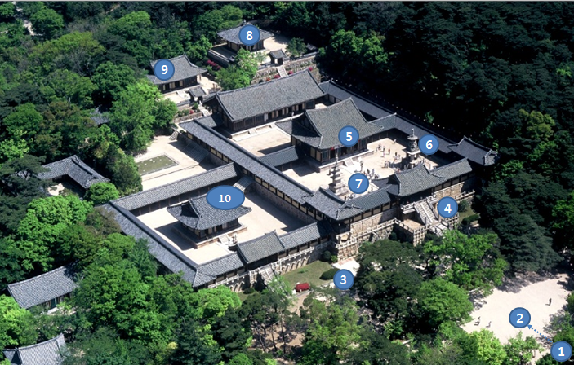
Fig. 3 Landmarks: The area of spatial cognition

Bulguksa Buddhist Temple is a UNESCO world heritage site and it meets Auge’s concept of the ‘place.’ In this temple, there are many cultural heritages including Dabotap pagoda, Seokgatap pagoda, 6 national treasures and 4 treasures; each classifies the temple as a semantic area, thus it features spatial difference. During experience of the physical space in the real world, many nodes and situations are shown as the depth of the space between starting point and destination. Concentrating the information by simplifying the depth of the space is effective in virtual reality space than real world. Therefore, Bulguksa landmarks can be simplified into 10 landmarks, and each landmark can be designated as gaze territory and node. Each node consisted with landmarks helps spatial practice, space between nodes is recognized as a path for the sight to jump.
Based on the landmarks, unit areas that exist within the physical boundary of virtual reality space are set to 10 areas; the area 3 and 4 and the area 5, 6 and 7 are regarded as a space to set the starting point at 1. When physical space of real world is reproduced into virtual reality space, the path for spatial practice should be set as the shortest path; spectacle should be organized by assigning each area as a node thus gaze and spatial practice will be fulfilled. In virtual reality space, the connection between movement and vision expand with the hierarchy of space as the starting point. Through the spatial practice that increases the space sense, users will increase the contents engagement and get sensory transition.

1 | 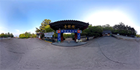 | 6 | 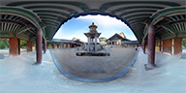
2 | 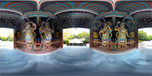 | 7 | 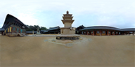
3 | 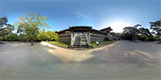 | 8 | 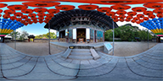
4 | 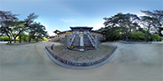 | 9 | 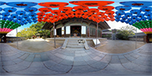
5 | 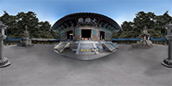 | 10 | 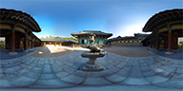
Fig. 3 Nodes in Reproduced Virtual Reality

VI. Conclusions and Future Works

Experience in virtual reality space transforms the space of observation into the space of experience. ‘Seeing’ is entering and immersing oneself into that virtual space for cognition; the act of paying attention can develop into the idea of residing in that space. This ultimately is a development from seeing to being. Spatial practice in virtual reality space results in interaction and experience based on visual perception. Also, interaction and understanding of sensory space based on user experience endows a sense of reality and existence, enabling contents immersion.
Spatial practice process is defined as real space is relationship between spaces; in virtual reality space, it expands more than the relationship. Therefore, physical reality space and virtual reality space reproduced on it signify the difference of recognition interaction process. In this thesis, landmark areas in virtual reality space are set as nodes and paths are organized to get connected to simplify the depth of the space.
By applying five image elements of spatial structure such as path, edge, node, district and landmark to the virtual reality space in a convergent form, the information concentration has been enhanced.
The possibility of interaction with space through fixation and saccade based on visual perception has been presented by applying spatial cognition elements for spatial practice in ‘non-places’ reproduced in a virtual reality space. In future, experiential quantitative evaluation in virtual reality space to which spatial structure image elements are convergent and applied will be conducted together with follow-up studies related to spatial syntax. It is expected to produce highly immersive virtual reality contents and evaluate such contents based on spatial practice through deeper understanding and reflection of virtual reality space and real existences.

References

[1] J. H. Lee, Classic concepts of humanities and social sciences reading mobile culture, Seoul: Communications Books, 2013.
- A. Marc, Non Places: An Introduction to Supermodernity, London: Verso, 1995.
- A. N. Mun, “Mobile Media and Spatial Practice,” The Korean Journal of Art and Media, vol. 15, no. 1, pp.133-160, February 2016.
- H. J. Jung, “The Place of Urban Architectural Space of Mobility in Marc Auge’s ‘Non-Place’,” Journal of the Architectural of Korea Planning & Design, vol. 31, no. 3, pp. 131-142, March 2015.
- M. Y. Kim, J. Y. Kim and Y. S. Hwang, “A Study on experientially-based understanding of place of Transmission Digital 3D Image Media,” Journal of Korea Institute of Spatial Design, vol. 10, no. 5, pp. 125-138, October 2015.
- J. D. Bolter, L. Grusin, Remediation: Understanding New Media, Massachusetts: MIT Press, 2000.
- M. McLuhan, Q. Fiore, The Medium is the Massage, London: Penguin Books, 1967
- M. M. Ponty, Phenomenologie de la Perception, London: Routledge, 1998.
- H. H. Park, “A Study on visual Perception for effective motion graphics,” Design Convergence Study, vol. 12, no. 4, pp. 115-128, August 2013.
- R. Gregory, Eye and brain, New Jersey: Princeton University, 1997.
- R. Solso, Cognitive and the Visual Art, Massachusetts: MIT Press, 1994.
- E. K. Ha, “A Study on the Structure of Spatial Experience by Digital Media,” Journal of Korea Institute of Spatial Design, vol. 22, no. 0, pp. 177-186, December 2012.
- L. Manovich. The Language of New Media, Cambridge. Massachusetts: The MIT Press, 2001.
- S. H. Lee, S. Y. Shin, “Transference from Physical space to sensorial space,” The Korean Journal of Art and Media, vol. 14, no. 2, pp. 55-74, May 2015.
- H. J. Jeon, H. S. Pak, T. S. Yun and E. J. Chae, “Non-places of Virtual Reality and Spatial Practice,” International Conference on Cultural Technology 2017, pp. 362-363, January 2017.
- J. H. Kim, E. K. Cho and Y. S. Ban, “A Study on Observation Type at the Process of Visual Understanding,” Korean Institute of Interior Design Journal, vol. 21, no. 2, pp. 92-100, April 2012.
- T. W. Park, “Study on Percipient’s Cognitive Reaction of Spatial Formative Elements,” Bulletin of Korean Society of Basic Design & Art, vol. 17, no. 1, pp. 245-256, January 2016.
- T. W. Park, “Study on Percipient`s Cognitive Reaction of Spatial Formative Elements,” Bulletin of Korean Society of Basic Design & Art, vol. 17, no. 1, pp. 245-256, January 2016

